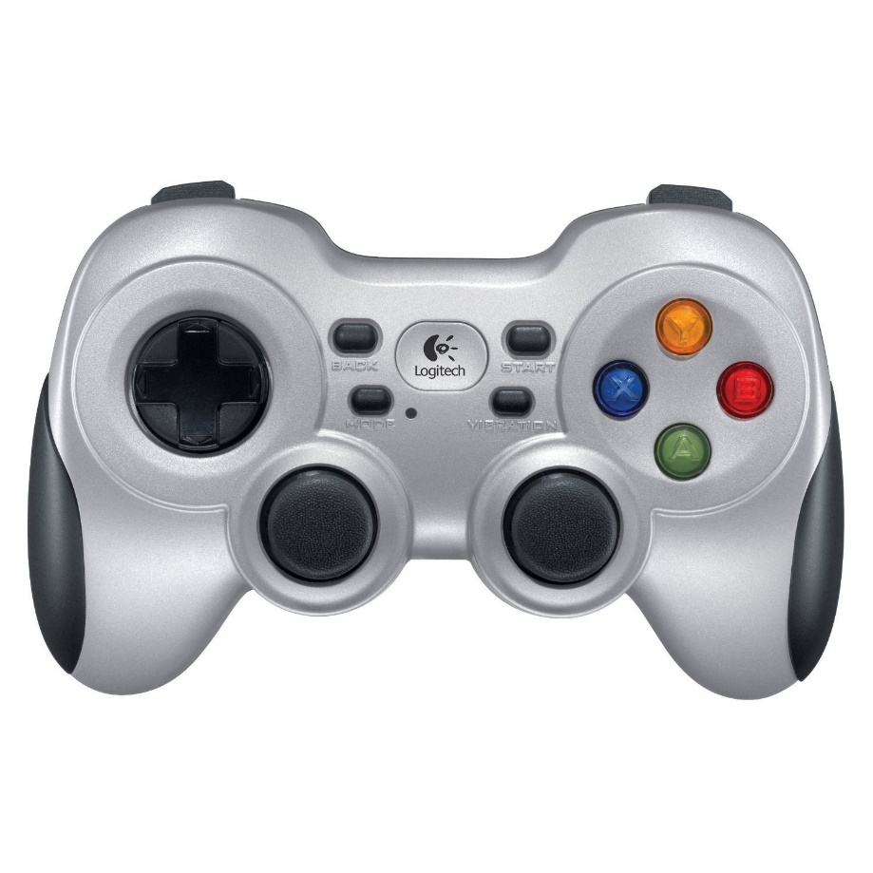

CORE MOVEMENT AND ACTIONS

-

Right-Top-Button : Dash

Press to activate Dash while your moving.

B-Button (or Button-2) : Block & Buff

Press B-Button to block an incoming object (ball).

Hold B-Button to activate Buff

A-Button (or Button-1) : Throw & Special Attack.

Press A-Button to throw the ball.

Hold A-Button to activate Special.

-

Left Analogue Stick: Core Movement

Use the Left Analogue Stick to move around your Character

 

Right-Top-Button : Dash (short range)

Dash can be used to travel a short distance very quick.

You will dash in the same direction as you are moving.

Dash has a short Cd.

If you dash into the ball, you catch it. At the End of the Dash you can quickly press B, if you dont want to catch, but block.

B-Button (or Button-2) : Block & Buff

You have to time your Block ! You cannot press and hold B-Button and wait to Block the object automatically !

Use it on the right time, when the object is in range or you wont block it.

If you successfully blocked it, the ball bounces off and gains Speed.

If you successfully blocked it, you gain Energy. Energy slowly fills up the Powerbar and can be used for Buffs and Special Attacks.

Buffs can be activated if you hold down B-Button for x-Time. Buffs can be activated in every situation.

A-Button (or Button-1) : Normal Throw & Special

After you catched the object, you are able to throw it back.

Simply press A-Button to throw it back in a straight line (no direction control 🡪 look at COMBINATIONS if you want to give the ball a direction)

Hold down the A-Button to charge your Specialattack. After its charged, let go the A-Button to release your power.

-

Left Analogue Stick: Core Movement

Just move the Left Analogue Stick to move around the field like a boss.

DESCRIPTIONS

-

COMBINATIONS

Throw in any direction:

To throw the ball in any direction you want,

1. **move and hold** the **Left Analogue Stick** in the direction you want to throw the ball and
2. press the **A-Button** to release/throw the ball.

Throw with spin:

To throw the ball with a spin,

1. **Hold down** the **A-Button,**
2. move the **Left Analogue Stick up or down** (keep it up or down till you let go the A-Button) and
3. **let go the A-Button** to throw the ball with a spin.

Up Spin : The ball flies in an up-curve.

Down Spin: The ball flies in a down-curve,